2) import java.util.*;

public class Main {

public static void main(String[] args) throws Exception {

Scanner sc = new Scanner(System.in);
System.out.println("Author:P.Vamsi sita ram\nSAP ID:51834793");
System.out.println("Enter the first string:");
String input = sc.nextLine();

System.out.println("Enter the second string:");
String rotation = sc.nextLine();

if (checkRotatation(input, rotation)) {
System.out.println(input + " and " + rotation
+ " are rotation of each other");
} else {
System.out.println("they are not rotation of another");
}

sc.close();
}

public static boolean checkRotatation(String original, String rotation) {
if (original.length() != rotation.length()) {
return false;
}

String concatenated = original + original;

if (concatenated.indexOf(rotation) != -1) {
return true;
}

return false;
}
}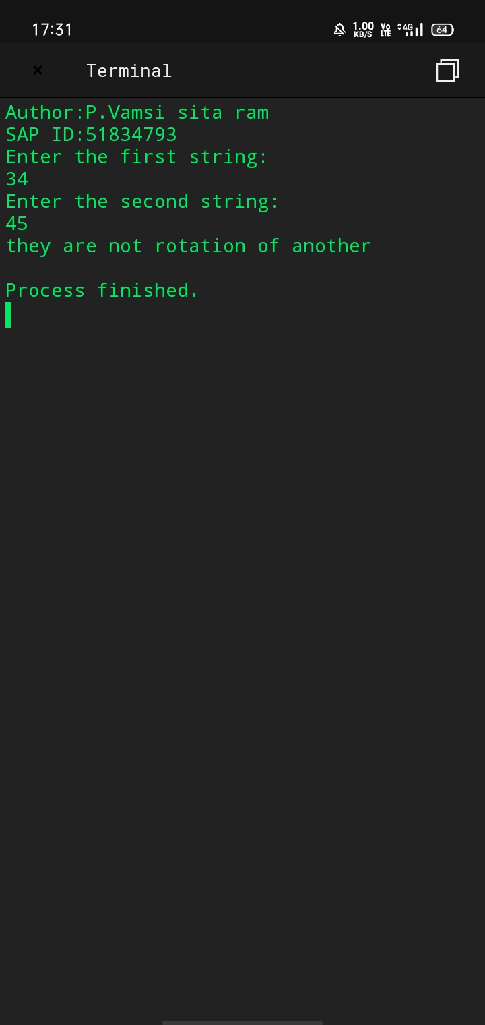

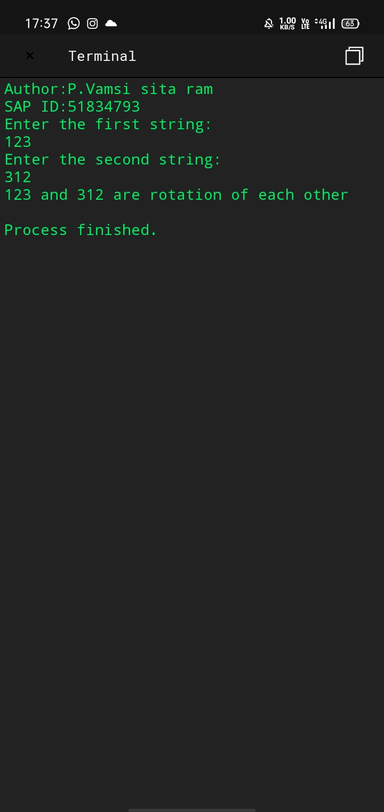

5) import java.util.Arrays;

class Main
{
public static void swap(int[] arr, int a, int b)
{
int temp = arr[a];
arr[a] = arr[b];
arr[b] = temp;
}

public static void bubbleSort(int[] arr, int x)
{
for (int a = 0; a < x - 1; a++) {
if (arr[a] > arr[a + 1]) {
swap(arr, a, a + 1);
}
}
if (x - 1 > 1) {
bubbleSort(arr, x - 1);
}
}

public static void main(String[] args)
{
int[] arr = { 3, 5, 8, 4, 1, 9, -2 };

bubbleSort(arr, arr.length);

System.out.println("Author:P.Vamsi sita ram\nSAP ID:51834793");
System.out.println(Arrays.toString(arr));
}
}
